Where To Find Things At The Pequot Library 2006 Book Sale!

Large Tent | Auditorium
Astrology & Occult | Art & Architecture
Atlases & Dictionaries | Biography
Business | Classics
Children’s | Coffee Table
Computer | Collectibles
CT, New England & NY | Erotica/Exotica
Current Fiction | History and Politics: Americas
Education & Text  Family & Parenting | European  World
Fiction | Old & Interesting
Foreign Language | Photography
Gardening & Nature | Poetry
Humor  Law & Crime  Maritime | Literature & Anthology – Writing &  Journalism
Military History
Mystery  Ologies – Social Sciences | Main Library  (until Saturday a.m.)
Pets & Animals | Specials
Science
Science Fiction | Young Readers Tent
Sets | (Sunday only)
Sports | “Like New” children’s books
Spy & Espionage
Transportation
Travel
Small Tent | Pequot Library  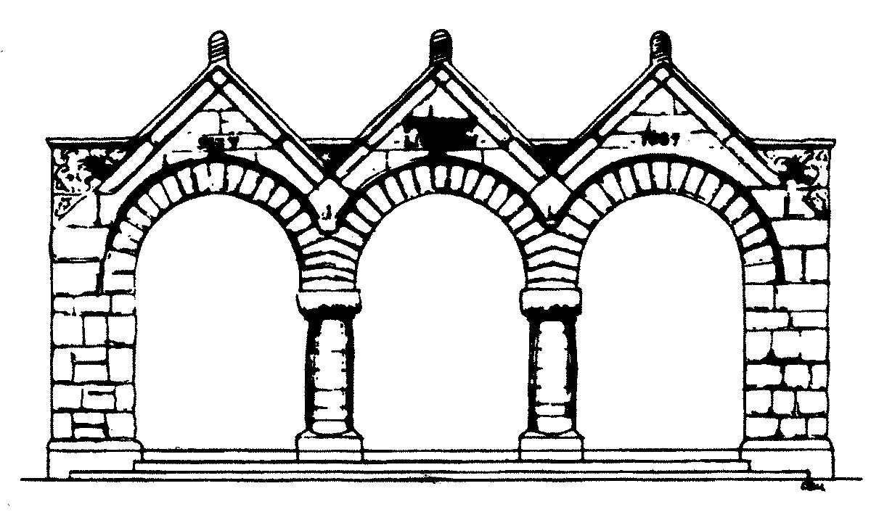
Cookbooks | 720 Pequot Avenue
Crafts & Hobbies | Southport, CT 06890
Diet & Nutrition | www.pequotlibrary.com
Health Care
Music | Visa and MasterCard accepted
Performing Arts
Records, CDs,& Cassettes  Videos/DVD | BATHROOMS are located in the Children’s Room
Religion & Philosophy
Self Help
 | (7/5/06 – list subject to change)

